

**Submitted by : Spogmai Jan**

**Roll No : 2430 – 0081**

**Submitted to : Sir Bilal Dar**

**Subject : PF LAB**

**Lab task :02**

**Problem statement : Jazz Cash Account Balance ….**

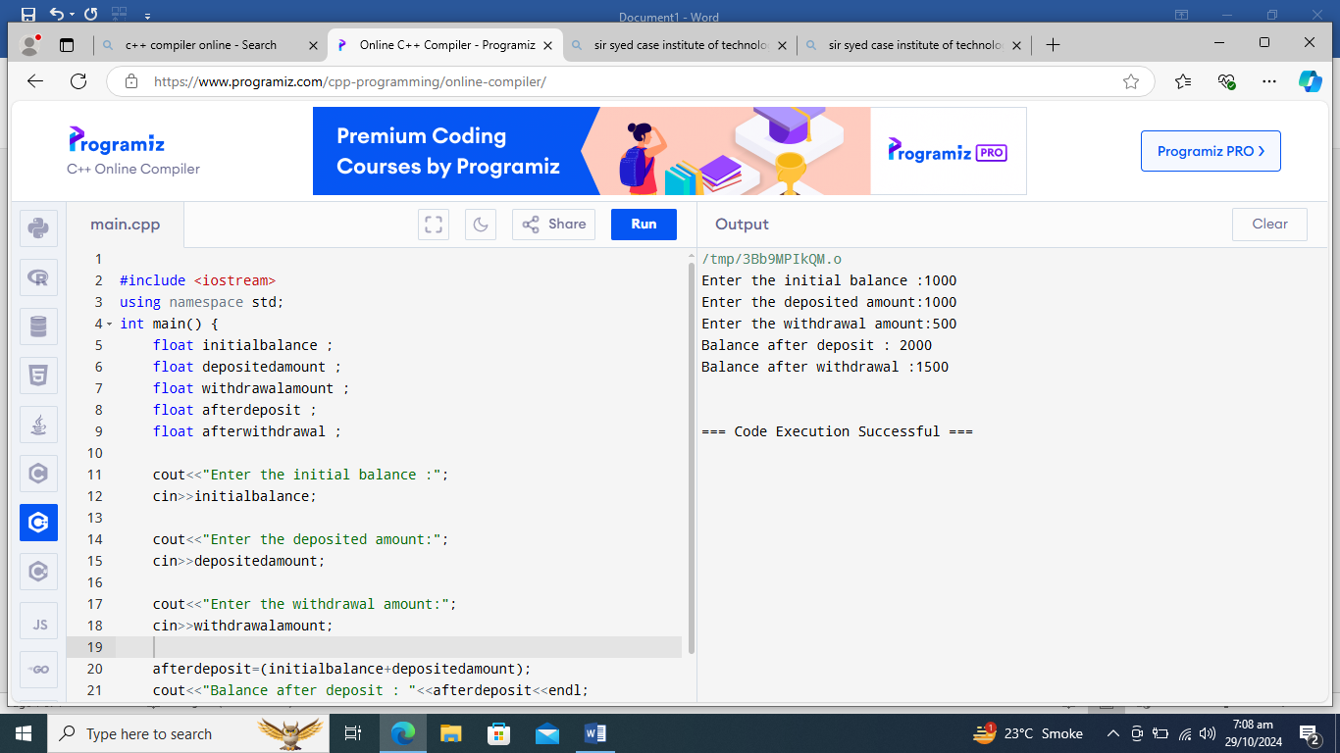

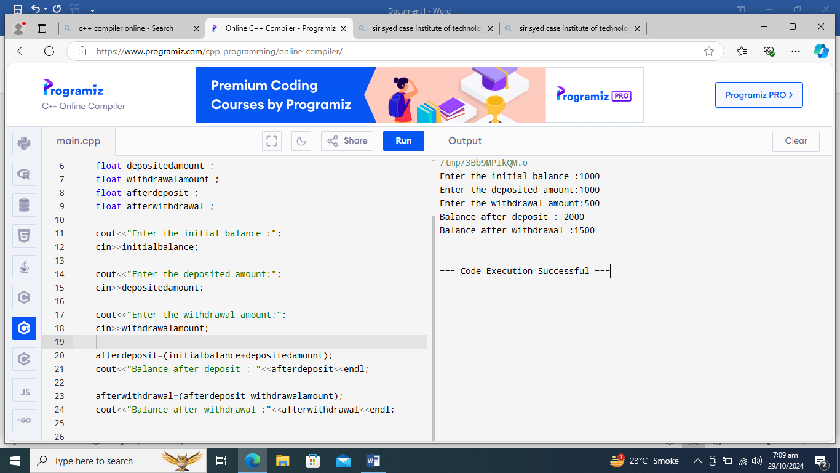

**------ The END ------**